**Capstone Assignment 3.3 – Analyze and Evaluate an Architecture**

Scenarios 1: Risk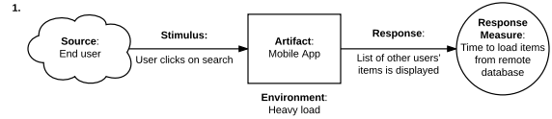

Reason: When the scenario of environment heavy load, there can be a large number of user request sending to the webserver requesting the access of the shared storage. The number of requests may exceed the volume the shared storage can handle. It will cause long delay and impact the latency measurement.

Scenarios 2: Risk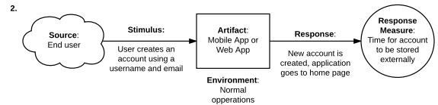

Reason: The user login step is skipped when user create new account. This increases the vulnerability of the system.

Scenarios 3: trade off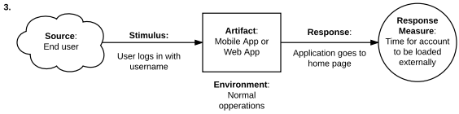

Reason: User only requests username to login increases the login response time. However, it decreases the system security, since only username is required to login, nothing else.

Scenarios 4: Non-risk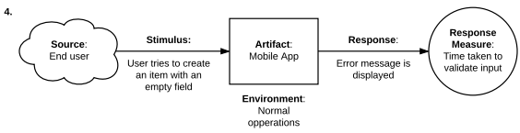

Reason: The system checked the user input data before sending it to central database. This can prevent SQL injection attack. This is an expected system behavior.

Scenarios 5: Non-risk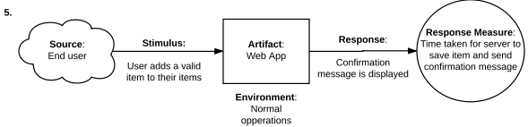

Reason: The system received a valid input from user and then perform the normal operation and response back to the user with confirmation message. This is an expected system behavior.

Scenarios 6: Sensivity point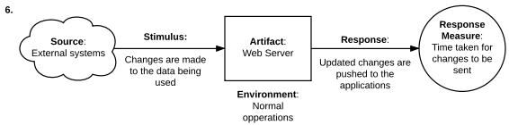

Reason: The application the user is using is containing the stale data that may decrease the usability of the application. Invert push strategy can prevent the user to keep refreshing the application and increase the overall performance.

Scenarios 7: Non-risk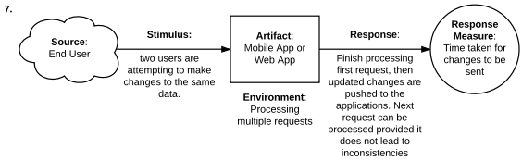

Reason: The system pipeline the request to change the same data. This prevent the issue of accessing the same data at the same point. Increase the system fault tolerance and data consistency.

**Updated Utility Tree**

Utility

Security

interoperability

Performance

Users can access their data from the Sharing Mobile App. (H)

Accessibility

Users can access their data from the Sharing Web App. (H)

A user cannot place a bit on their own items. (M)

A user can only edit items they own. (H)

Authorization

Authentication

A user must login the account to use the app. (H)

A user must create or have an account to use the app. (H)

It takes less than 5 second to response during heavy load. (H)

Latency

It takes less than 1 second to complete any given task. (H)